**📰** **Fitness meets food: SmartFoodie vending machine new at CrossFit Munich South**

**🤝 New location, new power**

SmartFoodie is now an official partner of **CrossFit Munich South** at **Hofmannstraße 7, 81379 Munich**!

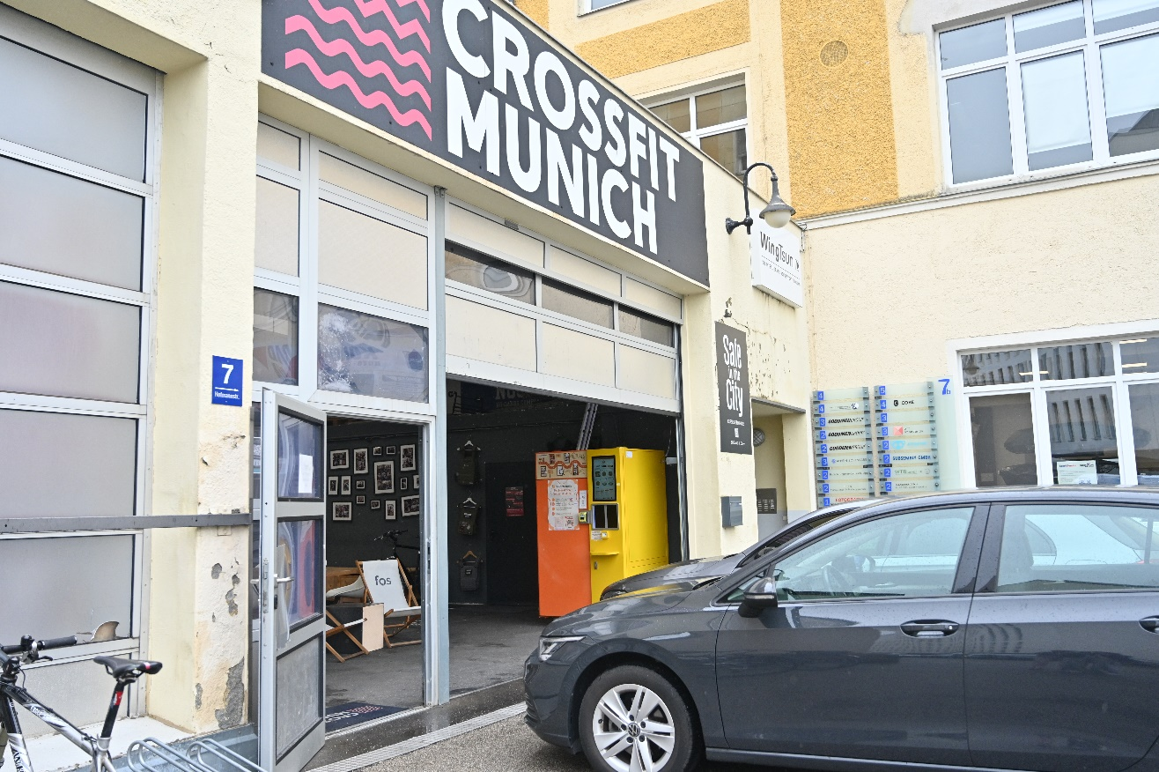From now on, you will find our fully automatic steam-cooking machines right in your gym – filled with freshly prepared meals that are a perfect fit for your active lifestyle. Whether before, after, or just in between workouts: In just **2** **minutes**, you can get **cold or hot meals** at the touch of a button via our SmartFoodie app – from hearty, protein-rich rice and meat dishes to fresh salads, dumplings and light desserts. Everything is carefully prepared, nutrient-rich and ready when you are.

💪 We are thrilled to now be part of the fitness community. With our new location right inside CrossFit Munich South, we are bringing our mission to where balanced eating truly matters into the everyday lives of active people.

It supplies the fitness community with delicious, nutrient-rich meals – quickly, easily and exactly when it matters most. We offer more than just good food: a smart solution that fits perfectly into the active and structured lives of modern fitness enthusiasts. Because we believe that **a balanced diet is the key to real progress – in training and beyond**.

📍 Try it now at **CrossFit Munich South (Hofmannstraße 7, 81379 Munich)**

🕘 Opening Hours:

Monday: 06:30 - 21:00

Tuesday: 06:30 - 21:00

Wednesday: 06:30 - 21:00

Thursday: 06:30 - 21:30

Friday: 06:30 - 21:00

Saturday: 08:30 - 15:00

Sunday: 09:30 - 12:30, 16:30 - 19:00

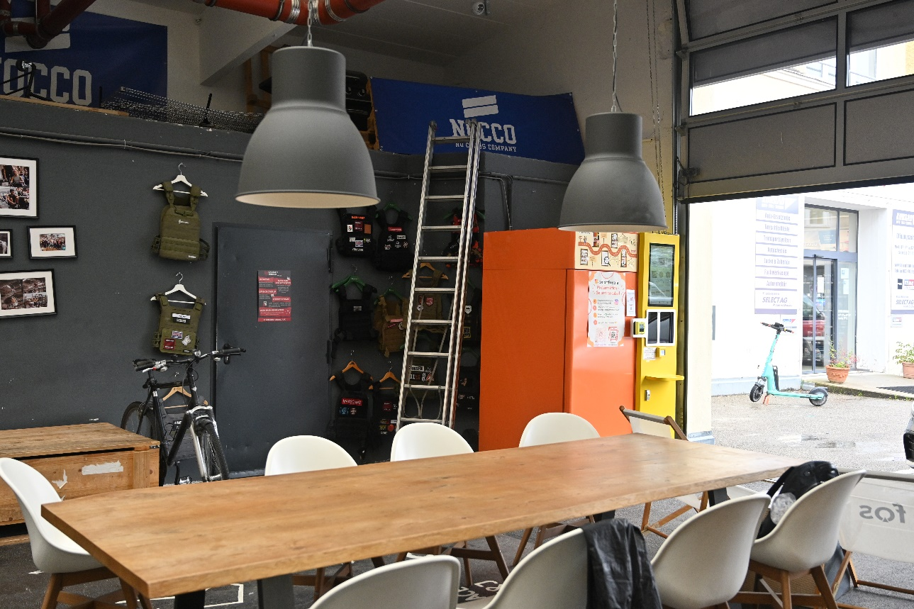

More locations are already being planned – we are constantly working to make fresh and delicious meals accessible to even more people.

👉 Get all the updates about SmartFoodie on **Instagram** [**@smartfoodie_gmbh**](https://www.instagram.com/smartfoodie_gmbh)!

👉 With the [**SmartFoodie app**](https://qrco.de/bfPKef), you can easily secure your food – pre-order or order directly📲